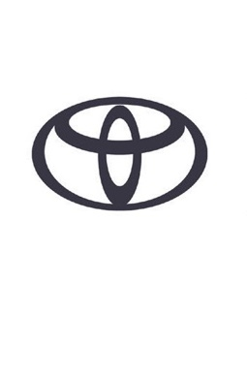
TOYOTA AYGO X – SPECIFICATIONS

POWERTRAIN
TYPE | 1KR-FE, 1-LITRE, 3-CYLINDER, IN-LINE
VALVE MECHANISM | 12-VALVE DOHC, CHAIN DRIVE WITH VVT-I
FUEL SYSTEM | DIRECT MULTIPOINT INJECTION
DISPLACEMENT (CM³) | 998
BORE X STROKE (MM) | 71.0 X 84.0
COMPRESSION RATIO (:1) | 11.8
POWER OUTPUT (DIN HP / KW @ RPM) | 72 / 53 @ 6,000RPM
TORQUE (NM @ RPM) | 93 / 4,400RPM

TRANSMISSION | CVT | MT
TYPE | S-CVT (K412) | MT (C554)
FINAL GEAR RATIO (:1) | 6.049 | 4.294
1ST | / | 3.545
2ND | / | 2.047
3RD | / | 1.310
4TH | / | 1.027
5TH | / | 0.850
6TH | / | /
REVERSE | / | 3.214

PERFORMANCE | CVT | MT
MAX. SPEED (KM/H) | 151 | 158
ACC. 0-100 KM/H (SEC) | 14.8 | 14.9
DRAG COEFFICIENT | 0.32

FUEL CONSUMPTION (L/100KM) | CVT | MT
WLTP COMBINED CYCLE | 4.9-5.2 | 4.7-5.0
FUEL TANK CAPACITY (L) | 35

CO₂ EMISSIONS (G/KM) | CVT | MT
EURO CLASS | EURO6D | EURO6D
WLTP COMBINED CYCLE | 110-117 | 107-114

CHASSIS
FRONT SUSPENSION | MACPHERSON STRUT
FRONT SUSPENSION STABILISER BAR DIAMETER (MM) & THICKNESS (MM) | Φ23.6 T2.6
REAR SUSPENSION | TORSION BEAM
STEERING  OVERALL RATIO (:1)  LOCK TO LOCK  MIN. TURNING RADIUS TYRE (M) | RACK&PINION  13.4  2.88  4.7
BRAKES  FRONT  REAR | VENTILATED DISC BRAKE WITH FLOATING CALIPER 1-CYLINDER (14”)  LEADING-TRAILING DRUM BRAKE
TYRES | 175/65R17, 175/60R18

EXTERIOR DIMENSIONS (MM)
OVERALL LENGTH | 3,700
OVERALL WIDTH | 1,740
OVERALL HEIGHT | 1,525
TREAD FRONT | 1,540
TREAD REAR | 1,520
WHEELBASE | 2,430
FRONT OVERHANG | 730
REAR OVERHANG | 540

CARGO (DM³ VDA)
CAPACITY (INCLUDING UNDER DECK BOARD)  UP TO TONNEAU COVER  UP TO ROOF | 231  269
CAPACITY (REAR SEATS DOWN UP TO ROOF) | 829

WEIGHT (KG)
CURB WEIGHT MIN | 940
MAX | 1,015
GROSS WEIGHT | 1,360
TOWING CAPACITY BRAKED | /
UNBRAKED | /

