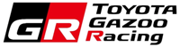
5 December, 2022
Toyota Motor Europe
GAZOO Racing Company

TOYOTA GAZOO RACING SET TO TAKE ON DAKAR 2023 WITH THREE-CAR TEAM

- Reigning champions Nasser Al-Attiyah and Mathieu Baumel to lead the way
- Giniel de Villiers and Dennis Murphy return to Dakar action
- Henk Lategan and Brett Cummings aim to impress on third outing
- The updated and even more brutal GR DKR Hilux T1+ ready to face stiff competition in the legendary rally

TOYOTA GAZOO Racing is set to take on the 2023 Dakar Rally with a three-car team early in January. The reigning masters, Nasser Al-Attiyah and co-driver Mathieu Baumel, will return to lead the way together with newly crowned South African Rally-Raid Champion Giniel de Villiers and co-driver Dennis Murphy, as well as Henk Lategan and Brett Cummings.

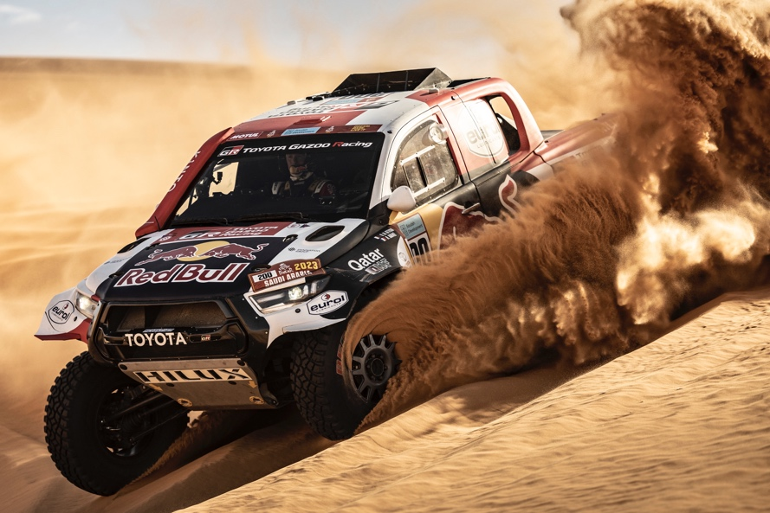
[Image: Marcin Kin/Red Bull Content Pool]

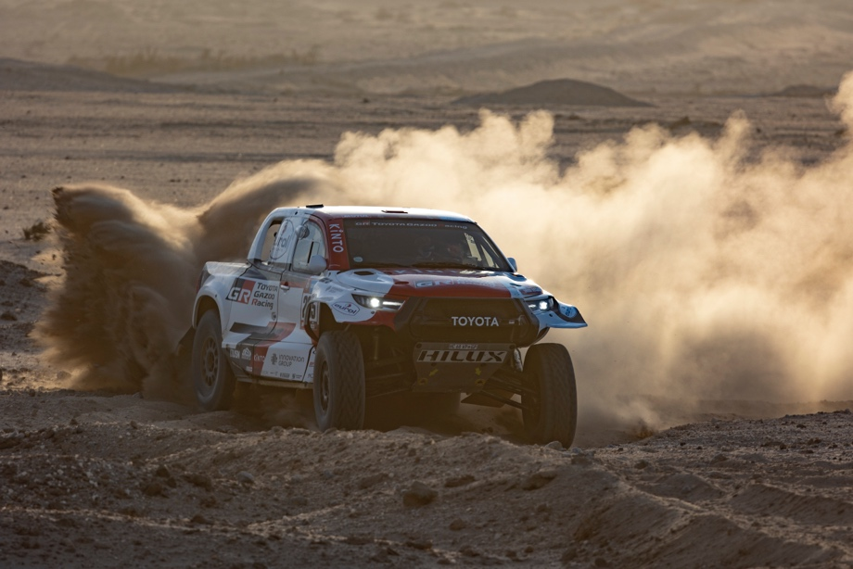
[Image: TGR]
This event will mark the start of the World Rally-Raid Championship (W2RC) 2023 season, with Nasser and Mathieu again taking on the world’s toughest cross-country races.

The duo will be competing in all five rounds of the FIA’s W2RC during 2023. The championship starts with the Dakar Rally in January, and will be followed by the Abu Dhabi Desert Challenge at the end of February; the Sonora Rally in Mexico during April and the Desafio Ruta 40 in Argentina at the end of August. The season will draw to a close with the Rally of Morocco, again scheduled for mid-October.

The two remaining crews will compete the rest of the season in the South African Rally-Raid Championship (SARRC) as part of TOYOTA GAZOO Racing South Africa (TGRSA), which also serves as a key component in the ongoing testing and development of the GR DKR Hilux T1+. In 2022, the seven-round SARRC was won by Giniel and the former champions Henk and Brett finished second in the championship considered one of the world’s toughest rally-raid series.

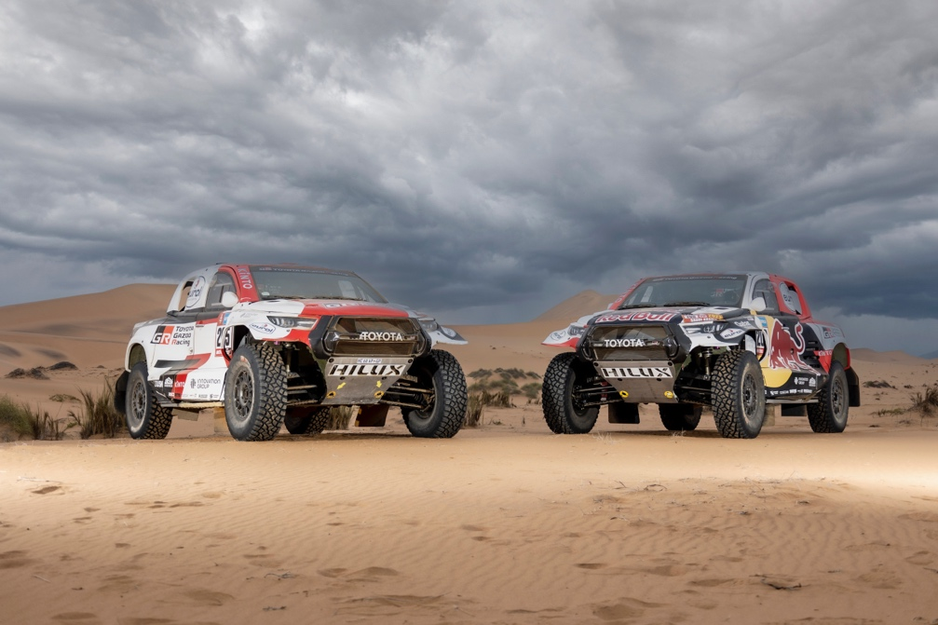
[Images: TGR]

The tough 2022 racing season offered TGR comprehensive opportunities to improve the Dakar-winning GR DKR Hilux T1+ in terms of quality, durability and reliability. In line with Toyota’s ethos of “Making Ever-better cars”, the team capitalised on more than 25,000km of racing and testing completed by its crews in both the W2RC and SARRC. Furthermore, the crews further built on their own competencies, thanks to 130 combined days on the road, securing both the W2RC and SARRC titles for the team.

For the 2023 season, the FIA has refined its criteria aimed at balancing the performance between the Class T1+ vehicles, and their counterparts in Class T1U (ultimate). The primary focus of the updated rules is to close up the field, making competition even tougher. For example, both the Class T1+ and T1U cars have had their peak power output reduced by 30kW. The power curves have been adjusted to blend the change proportionately, and the altitude compensation for turbo powered T1+ cars has been removed.

At the same time, TGR has been constantly upgrading the GR DKR Hilux T1+, with the aim of improving its quality, durability and reliability even further, ensuring that the car is fully prepared for the rigours of the Dakar Rally, the W2RC and the SARRC. As such, improvements have been made to the car’s differentials, suspension parts and wishbones, which have been reinforced. The single damper setup has also been optimised, as has the transmission’s shifting characteristics. Finally, the software has been tweaked to accept the latest racing fuel, and to ensure that the car conforms to the Balance of Performance requirements as set out by the FIA.

The team’s commitment to the development of the GR DKR Hilux T1+ is reflected by the privateer racing community, with seven privately entered versions of the car signed up for Dakar 2023. These cars sport similar setups and specifications to the GR DKR Hilux T1+ campaigned by the factory entry.

TGR also supports Team Land Cruiser Toyota Auto Body (TLC), a rally team of Toyota Auto Body Co., Ltd. that competes in the Toyota Land Cruiser. In the 2022 Dakar Rally, it achieved its ninth consecutive victory in the production car category. In the 2023 Dakar Rally, the team will enter a new Land Cruiser 300 GR SPORT and aim for their 10th straight victory in the production car category.

HINO TEAM SUGAWARA entered the 2022 Dakar Rally with a vehicle equipped with a racing hybrid system for the first time, and finished 22nd overall in the truck category. In the 2023 Dakar Rally, they will participate in a truck equipped with an improved hybrid system.

Dakar 2023 is set to start on 31 December, 2022 on the North Western coast of Saudi Arabia, before traveling inland towards the city of Ha’il. From there, the route continues in a South-easterly direction, bisecting the feared Empty Quarter, before finally swinging northwards towards the finish at Dammam, on 15 January, 2023.

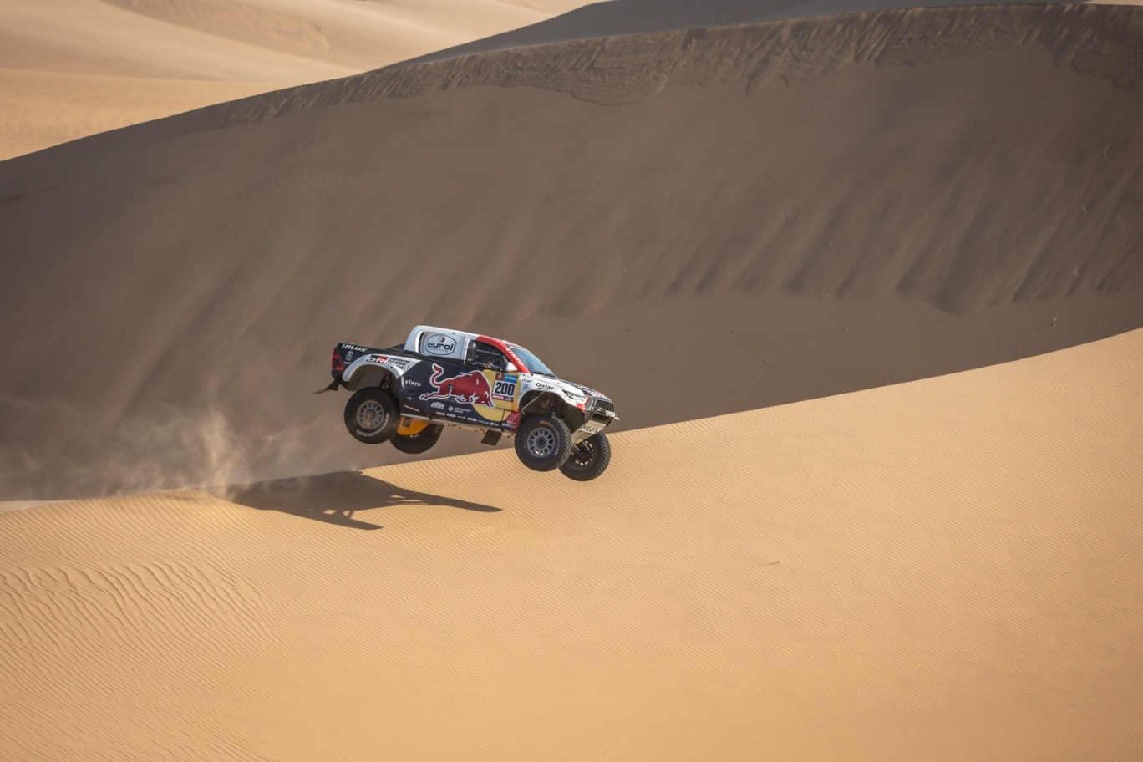
[Image: TGR]

QUOTES:
Alain Dujardyn, TGR W2RC Team Principal: “This year has been a fantastic one for us. We started by winning Dakar 2022, before adding the inaugural W2RC title to our list of achievements. Giniel also won the SARRC this year, and I would like to thank all three our crews for their respective achievements in both the W2RC and SARRC. They constantly pushed the limits for better, and the technical mastermind of Glyn Hall worked tirelessly to continuously improve our all-winning race car, making it ever-better in preparation for Dakar 2023.”

Glyn Hall, TGR Dakar & SARRC Team Principal and Technical Director: “Dakar 2023 is around the corner, and we are excited to take on the world’s toughest automotive race with a three-car team in January. We’ve worked hard at refining our GR DKR Hilux T1+ over the course of the year, and we’re confident that we are well-prepared to take on the rigours of the race, as well as our competition.

Nasser Al-Attiyah: “Winning the 2022 W2RC title was my first goal, and I’m proud to say that we achieved it. Also, the car has been getting steadily better throughout the year, and with a final test in Namibia, I’m sure that we’ve locked in the best possible version of the GR DKR Hilux T1+yet. Now, all that remains is to go racing in Saudi Arabia.”

Giniel de Villiers: “This year has offered some tough challenges, especially in terms of the SARRC. With that said, we managed to prevail to win the 2022 title, and as such we’ve grown considerably as a team. The car has also matched our personal growth, and we are excited to be back at the Dakar Rally this January. Winning the SARRC title has affirmed our belief that we are in the mix for overall victory this January, and we can’t wait for the race to start.”

Henk Lategan: “Dakar 2022 offered a steep learning curve, and I’m pleased with our experience earlier this year. Now, it is time to face the challenge yet again, but this year we are considerably more experienced, and the GR DKR Hilux T1+ is better than ever. Let’s get going in Saudi Arabia!”

CAR NUMBERS:
200 - Nasser Al-Attiyah / Mathieu Baumel
205 - Giniel de Villiers / Dennis Murphy
217 - Henk Lategan / Brett Cummings

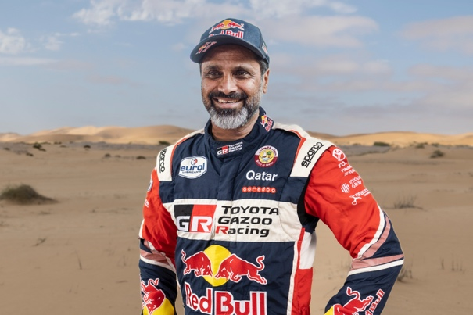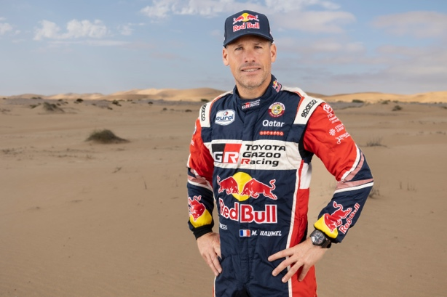
Nasser Al-Attiyah / Mathieu Baumel [Images: TGR]

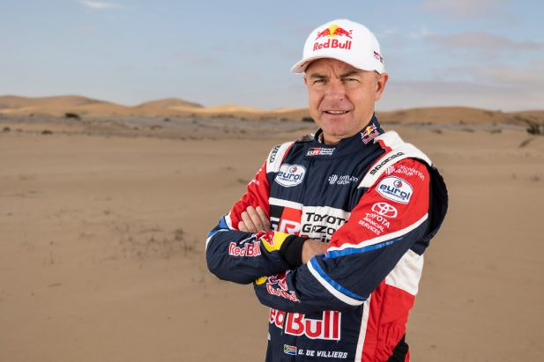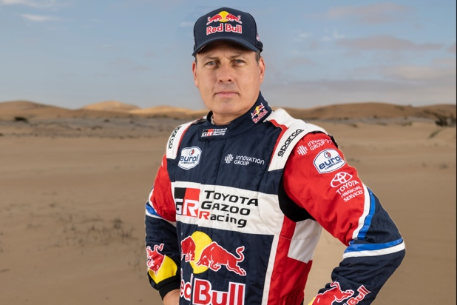
Giniel de Villiers / Dennis Murphy [Images: TGR]

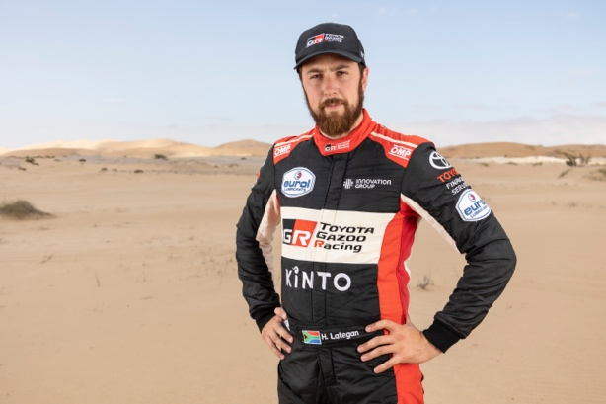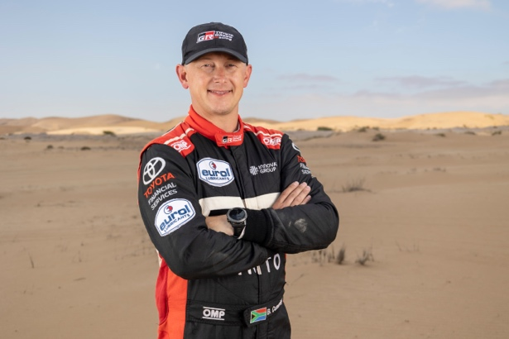
Henk Lategan / Brett Cummings [Images: TGR]

SPECIFICATIONS: GR DKR HILUX T1+ (2023)
Engine - V35A Production Engine
Donor - Land Cruiser 300
Engine Type - Twin Turbo, Petrol
Control Regulation - Boost Limited by FIA Reference Power Curve
Power - 266 kW @ 5,100 rpm
Torque - 620 Nm
Engine Management - Motec
Transmission - Sadev 6-speed, Sequential Shift
Differentials - All Limited Slip (front, centre, rear)
Clutch - Ceramic Twin Plate, 215 mm
Construction - Tubular Frame
Wheel Base - 3,140 mm
Overall Length - 4,810 mm
Overall Width - 2,300 mm
Overall Height - 1,890 mm
Overall Mass - 2,000 kg, FIA Regulated Minimum (dry weight)
Body - Toyota Hilux Double Cab Pick-Up, Full Composite
Front Suspension - Double Wishbone, 350 mm Travel
Rear Suspension - Double Wishbone, 350 mm Travel
Wheels - Evo Course, 17 inches
Tyres - BF Goodrich, 37 inches
Fuel Tank - FT3 Safety Cell, 540 litres

DAKAR RALLY 2023―TGR TEAM SETUP
Team | No. | Driver / Co-driver
TOYOTA GAZOO Racing | 200 | Driver | Nasser Al-Attiyah (Qatar）
 |  | Co-driver | Mathieu Baumel (France）
 | 205 | Driver | Giniel de Villiers (South Africa）
 |  | Co-driver | Dennis Murphy (South Africa）
 | 217 | Driver | Henk Lategan (South Africa）
 |  | Co-driver | Brett Cummings (South Africa）

DAKAR RALLY 2023―TLC TEAM SETUP
Team | No. | Driver / Co-driver
Team Land Cruiser / Toyota Auto Body (TLC) | 246 | Driver | Akira Miura (Japan）*
 |  | Co-driver | Laurent Lichtleuchter (France）
 | 250 | Driver | Ronald Basso (France）
 |  | Co-driver | Jean-Michel Polato (France）
* Toyota Auto Body Employee

DAKAR RALLY 2023―HINO TEAM SUGAWARA TEAM SETUP
Team | No. | Driver / Co-driver
HINO TEAM SUGAWARA | 519 | Driver | Teruhito Sugawara (Japan）
 |  | Co-driver | Hirokazu Somemiya (Japan）
 |  | Mechanic | Yuji Mochizuki (Japan）

MAJOR ACHIEVEMENTS IN 2022
World  Championships | Dakar Rally | -TGR:  1st overall (Nasser Al-Attiyah / Mathieu Baumel)  -TLC:  Ninth consecutive victory in the production car category  (Akira Miura / Laurent Lichtleuchter)  -HINO TEAM SUGAWARA:  22nd overall in the truck category  (Teruhito Sugawara / Hirokazu Somemiya / Yuji Mochizuki)
 | FIA World Rally Raid Championship  （W2RC） | TGR: 1st overall  (Nasser Al-Attiyah / Mathieu Baumel)  - TLC and HINO Team Sugawara only participated in Dakar Rally.

Two of TOYOTA GAZOO Racing W2RC's key sponsors, Red Bull and Eurol, have committed to share in the team's W2RC journey for 2023, supporting Nasser and Mathieu's efforts through TGR. Eurol is the Dutch developer and producer of lubricants, additives, cleaners, technical fluids and specialty products, available in over 90 countries worldwide. Innovation, quality and sustainability are core values of the Eurol brand. Eurol provides TOYOTA GAZOO Racing with the Eurol Specialty Racing line with SYNGIS Technology, for extreme high-performance levels under all circumstances.

Red Bull has established itself as the premiere supporter of extreme sports and athletes, and as such fits perfectly with TOYOTA GAZOO Racing's Dakar and W2RC efforts. The Austrian energy drink manufacturer has partnered with Nasser, Mathieu and TGR over numerous years, and the involvement bore fruit when Nasser and Mathieu won a second Dakar title for TGR in January 2022.

The team is also supported by Jonsson Workwear and USN.
